Course Name: | Structured Programming methodology | Semester: | I
Date of Performance: | 25/09/2025 | DIV/ Batch No: | D3
Student Name: | Ralston Kenneth Dsouza | Roll No: | D73

Experiment No: 2
Title: Use of decision-making control structures

Aim and Objective of the Experiment:
Write a program in C++ to demonstrate the use of decision-making and branching control structures

COs to be achieved:
CO2: Demonstrate the use of control structures

Theory:
An if-else statement is a conditional statement that executes a different set of statements based on the condition that is true or false.
Syntax:
if (condition) {
//code
}
else {
//code
}

A switch statement is a conditional statement used to check the value of a variable and compare it with all the cases. If the value is matched with any case, then its corresponding statements will be executed.

Syntax :
switch (expression) {
case value1:

break;
case value2:

break;
default:}

Problem Statements:
Write a program for the following:
- The marks obtained by a student in a subject are entered through the keyboard. The program should calculate the student's grade based on their marks using if–else statements.
The grades are awarded as follows:
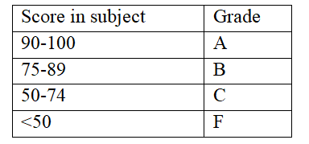

- Enter a number (1–7) through the keyboard and display the corresponding day of the week using switch case statements.

Number | Day
1. | Sunday
2. | Monday
3. | Tuesday
4. | Wednesday
5. | Thursday
6. | Friday
7. | Saturday

Flow chart:
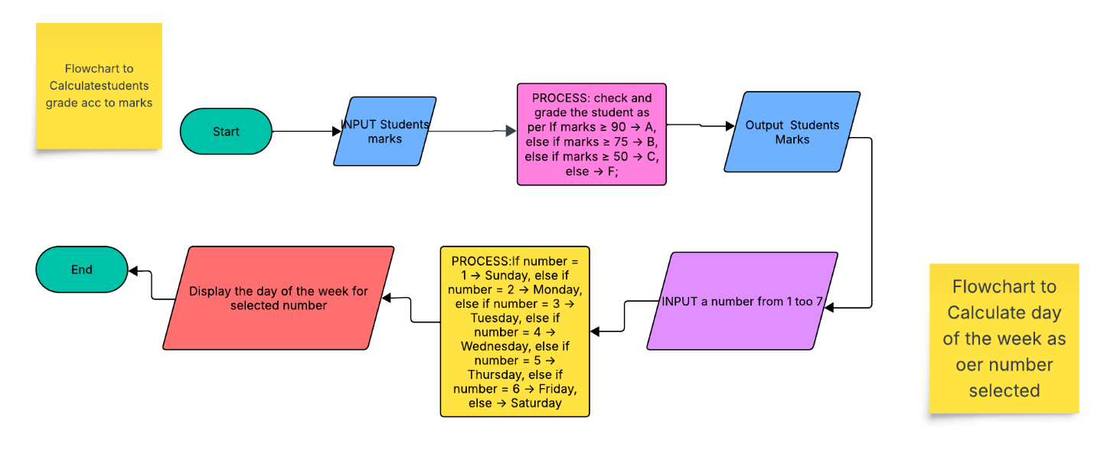

Code:
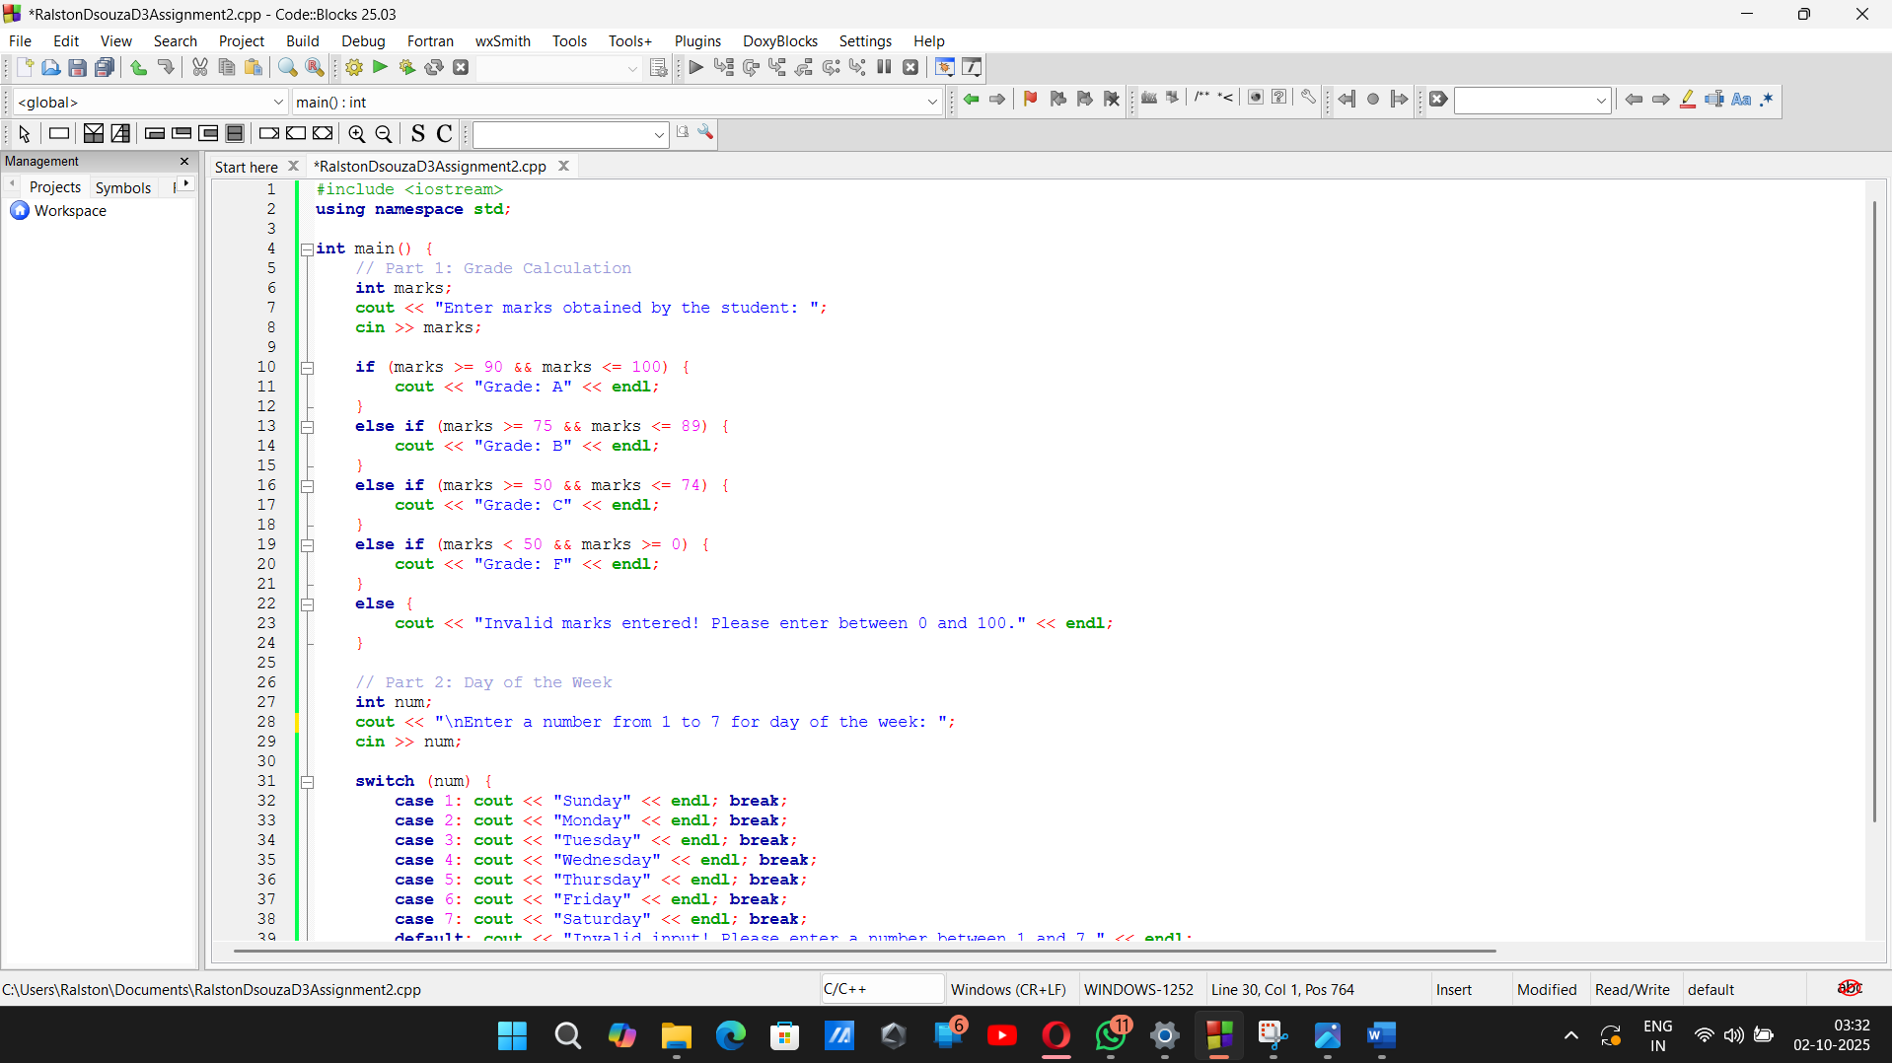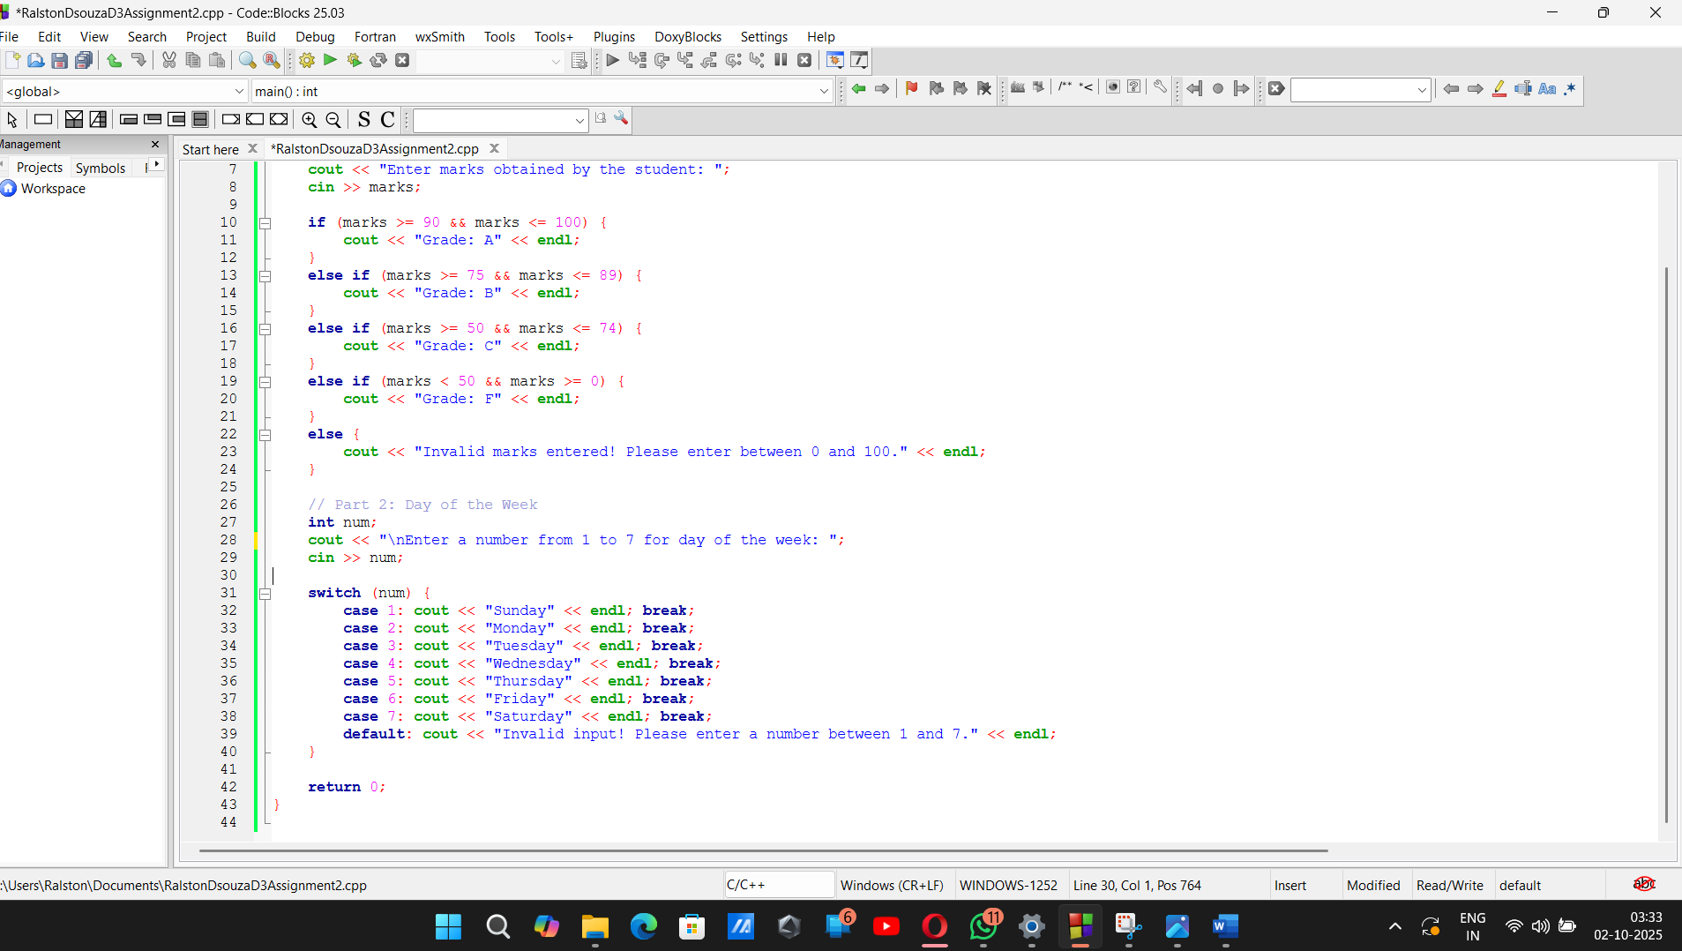

Output:
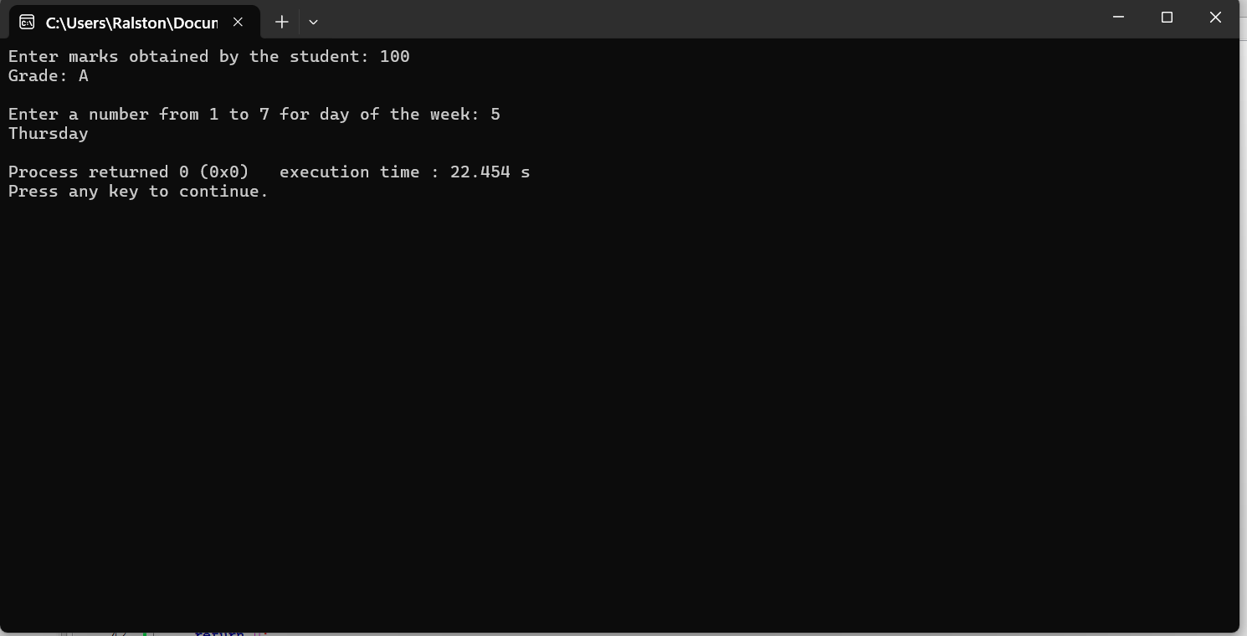

Post Lab Subjective/Objective type Questions:
Write a C++ program to ask the user to input a number. Check whether the number is even or odd.
Solve the problem using:
- if–else statement
- Ternary operator 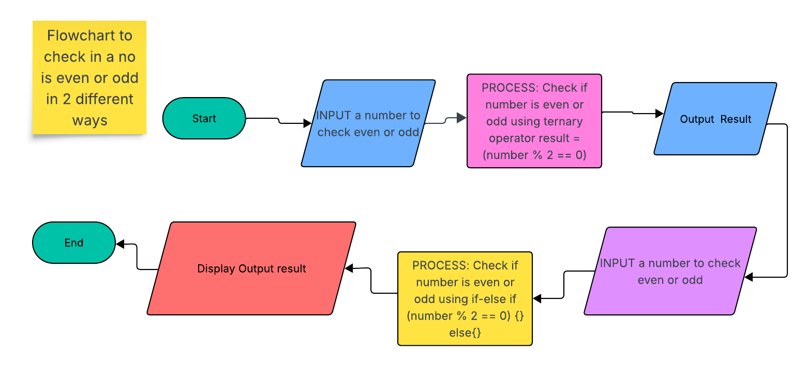
- 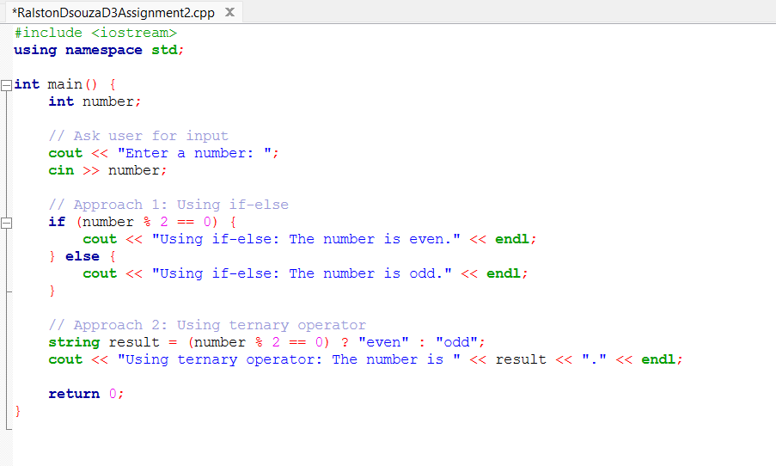
Write program to demonstrate the use of Switch case and if else ladder. 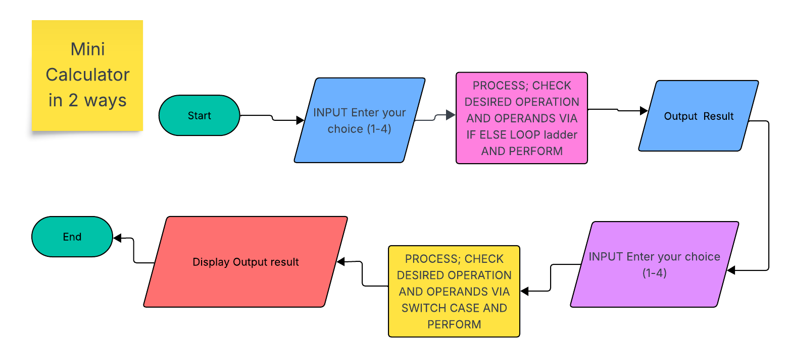
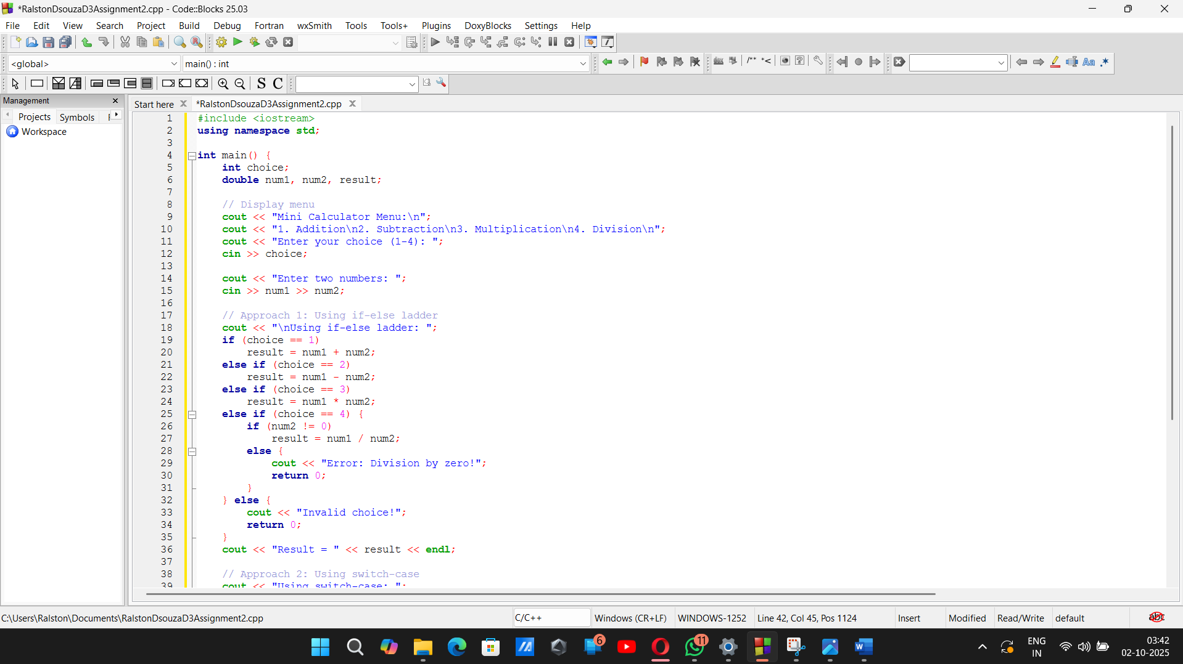

Conclusion:
Conclusion of the experiment: In this assignment, we learned how to use if-else ladders and switch-case statements in C++. The if-else ladder is useful when we need to check ranges or multiple conditions, while switch-case is cleaner and easier when we have specific values to check. By creating examples like grading students and a mini calculator, we understood how these decision-making tools work in real programs. Overall, this experiment helped us practice writing logical and organized code that can handle different situations based on user input.

Signature of faculty in-charge with Date:

